**TITLE: ENCRYPTION USING STEGANOGARPHY AND CRYPTOGRAPHY**

**Abstract**

Our present generation is obsessed with security of data that’s being exchanged digitally through different platforms. In order to maintain confidentiality, Integrity and accessibility (CIA Triad) we need good techniques. Steganography is the art of concealing information and Cryptography is an advanced mathematical approach to encrypt the data. One method covers the limitation of the other. The message can be encrypted using cryptographic algorithms and can safely be hidden using steganography. These well known techniques of data security keep the message to be delivered confidential and unaltered.

***Approach:***

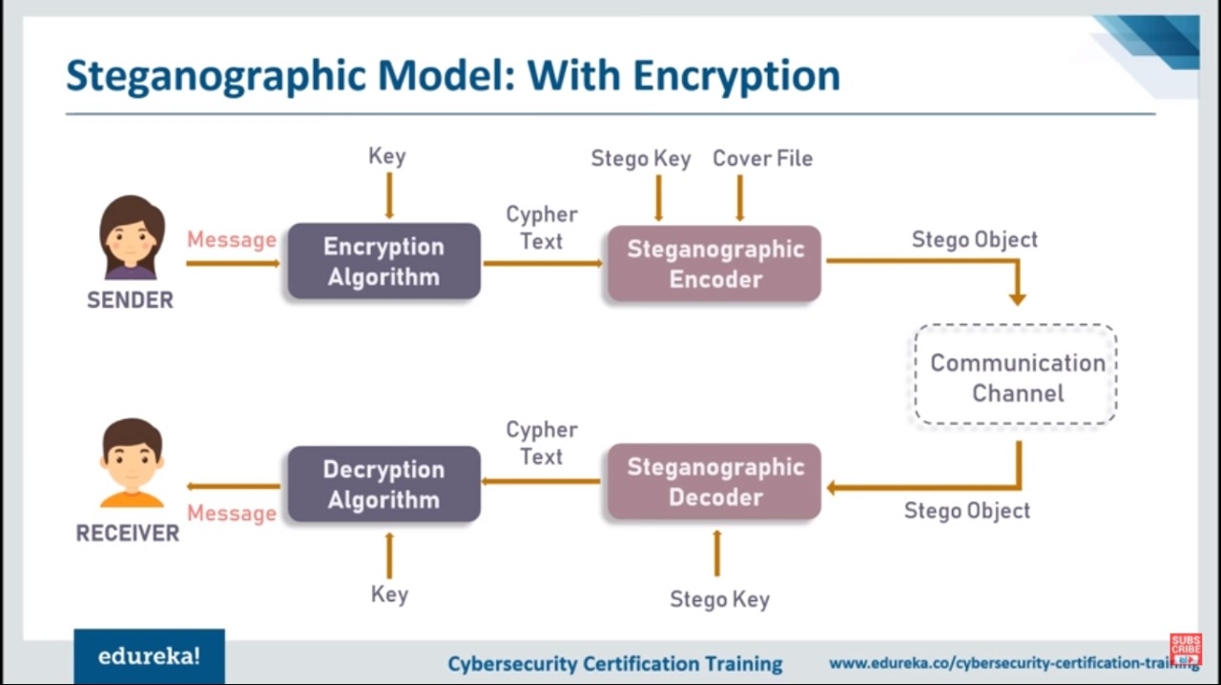

In this application the message to be encrypted and cover image are taken as inputs. Using cryptographic algorithms such as RSA (Rivest–Shamir–Adleman: asymmetric approach), AES (Advanced encryption standard: symmetric approach) and stenonographic algorithms such as LSB (Least Significant Bit), DCT (Discrete Cosine Transform) the plain text is encrypted. The cryptographic key is kept secret. This cipher text is taken as input string for the image and stego-image is generated. The image acts as perfect cover for the message. When the stego-image is decoded, cipher text is obtained. Decryption of this cipher text lets the intended message to be revealed. This application produces the image that contains cipher text as output.

Control Flow:

* Signup, login page
* Text hiding page (admin)
* User profile page – history, profile (personal details, friends), give access to friends

Applications:

* To hide any important information
* Transferring any data confidentially

1602-19-733-118 SVN Ramakanth

1602-19-733-119 V Venkateswarlu Gupta